Important Cluster Command Output-

kubectl get pods

kubectl get ns

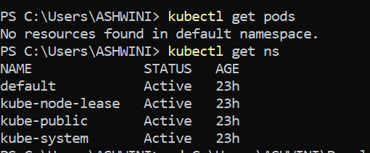

kubectl create namespace easyclaim

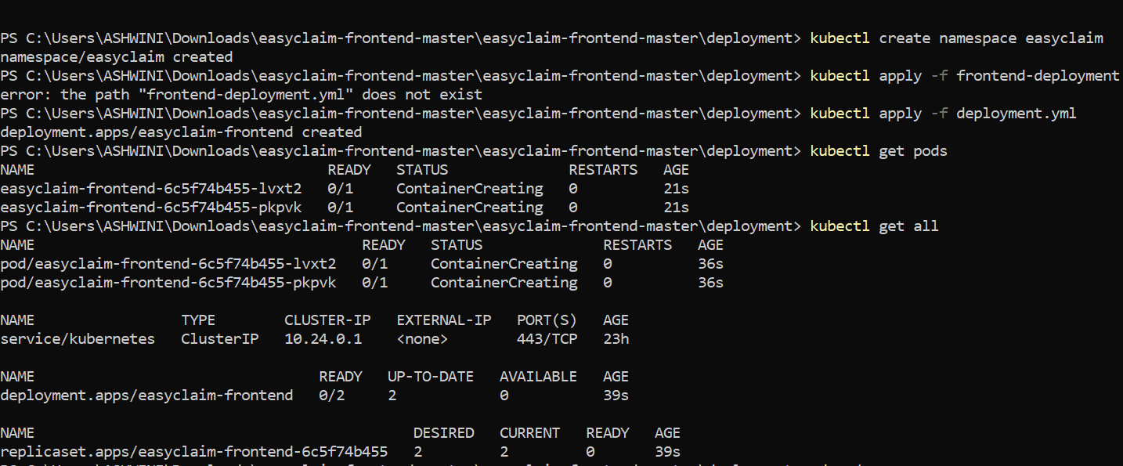

Commands to deploy backend container-

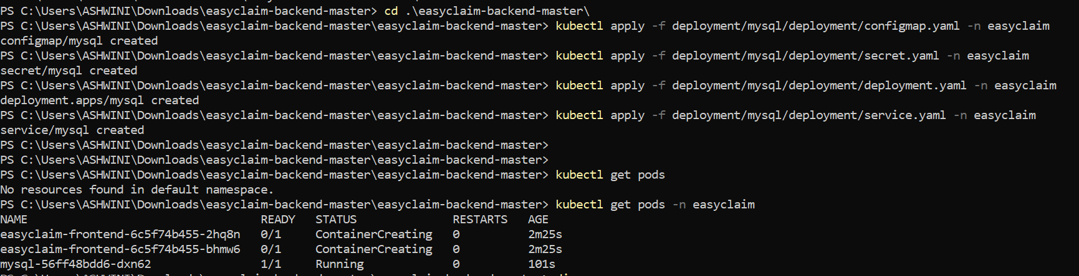

Commands to deploy frontend container-

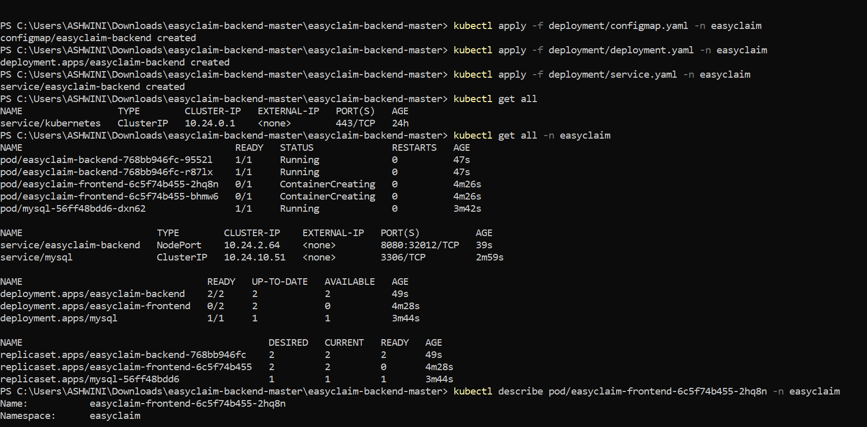

Command to check nodes and deployed container on pods-

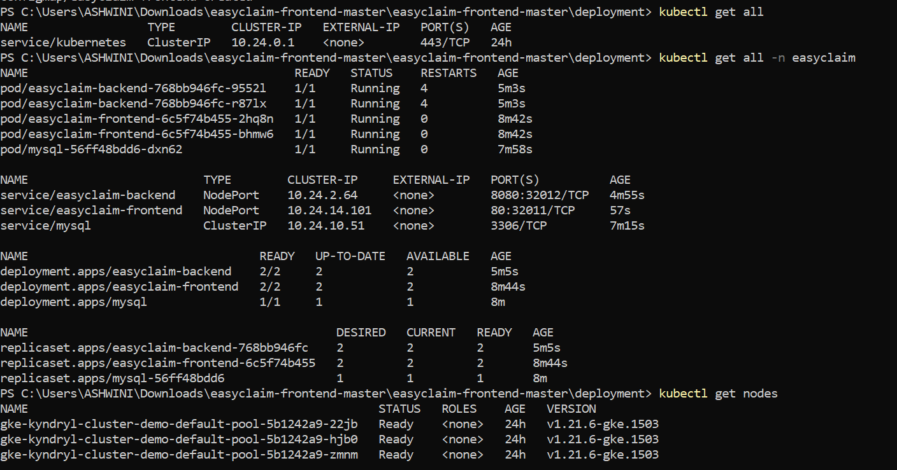

Command to get external IP address of the nodes-

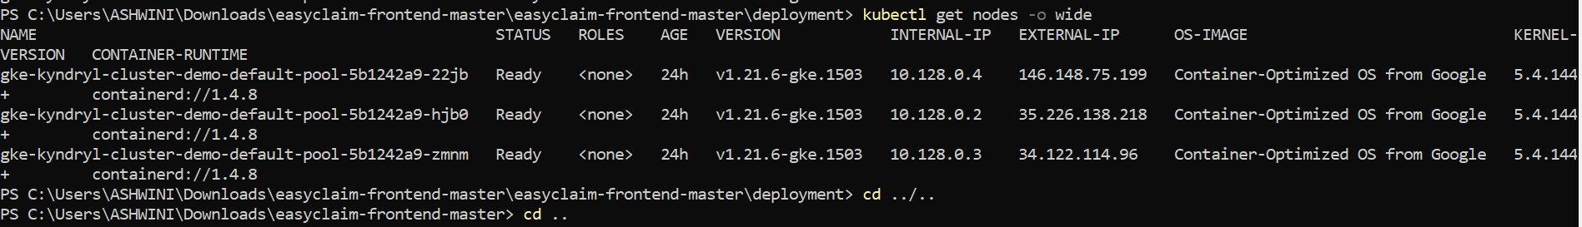

Add Firewall rule through GCP console and hit the URL through browser to access the application-

<http://35.226.138.218:32011/>

<http://146.148.75.199:32011/>

<http://34.122.114.96:32011/>

